**National University of Computer and Emerging Sciences**



Lab Manual

“Introduction to NASM, Debugger and Assembly Language”

COMPUTER ORGANIZATION AND ASSEMBLY

LANGUAGE

Department of Computer Science

FAST-NU, Lahore, Pakistan

**ASSEMBLY TOOLS AND ENVIROMENT**

3 tools you need for this course:

Nasm (An assembler)

Afd (A debugger)

Dosbox (A virtual box)

Follow given steps:

1. You can get these tools from

**\\sandata\Xeon\Fall2017\Farwa Batool\Assembly_Tools**

**Create a folder on your Z drive name as “Assembly”, copy portable dosbox , nasm and afd from xeon and past in folder.**

**Other tools are for your laptops, on a 32 bit machine you can run nasm and afd but on 64 bit machine you need Dosbox , you may install dosbox or use portable, you can’t run nasm and afd on a 64 bit machine.**

1. Open portable DOSBox folder, run application file in it.
2. By default the drive is ***Z:\*** .
3. Type command ***mount X Z:\Assembly.*** This will virtually create a drive X and ***Z:\Assembly*** will contain contents for this drive.
4. Still drive is **Z:\**, **X** is only mounted, to change drive or directory write **X:** and then press enter. You are done.
5. You can write these **mount commands at the end of** **.confg** file in portable dropbox folder, it will save your time. Next time when you open dropbox, you don’t have to mount again.

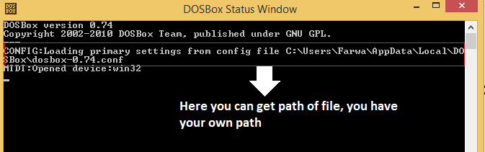

***Remember:*** *Honesty always gives fruit (****no matter how frightening is the consequence****); and*

*Dishonesty is always harmful (no matter how helping it may seem in a certain situation)!*